Compiled by Sean Gosiewski, Executive Director, Alliance for Sustainability
612-250-0389 sean@afors.org , www.afors.org/congrgations

Let’s meet our State’s Climate goals, while building racial equity & shared prosperity!
MN Has a goal and plan to reduce CO2 by 80% by 2050 – while strengthening our economy
- CSEO Report https://www.eqb.state.mn.us/sites/default/files/documents/CSEO_EQB.pdf
- The Met Council has adopted this goal and is encouraging metro cities to do the same http://metrocouncil.org/Handbook/Plan-Elements/Resilience.aspx
- This will create good paying jobs Minnesota's Clean Energy Economy /MN DEED Report https://mn.gov/deed/data/research/clean-energy-economy
- But we still need to make progress on equity Racial Disparities in Employment Outcomes After College http://mn.gov/deed/data/data-tools/graduate-employment-outcomes/race-geo.jsp
Levels of action – reducing CO2 – with
- Your congregation’s building
- Your congregation’s members
- Your Community – other congregations and your city
- Our state, nation and world
From our MN State Climate action plan www.eqb.state.mn.us/content/climate-change
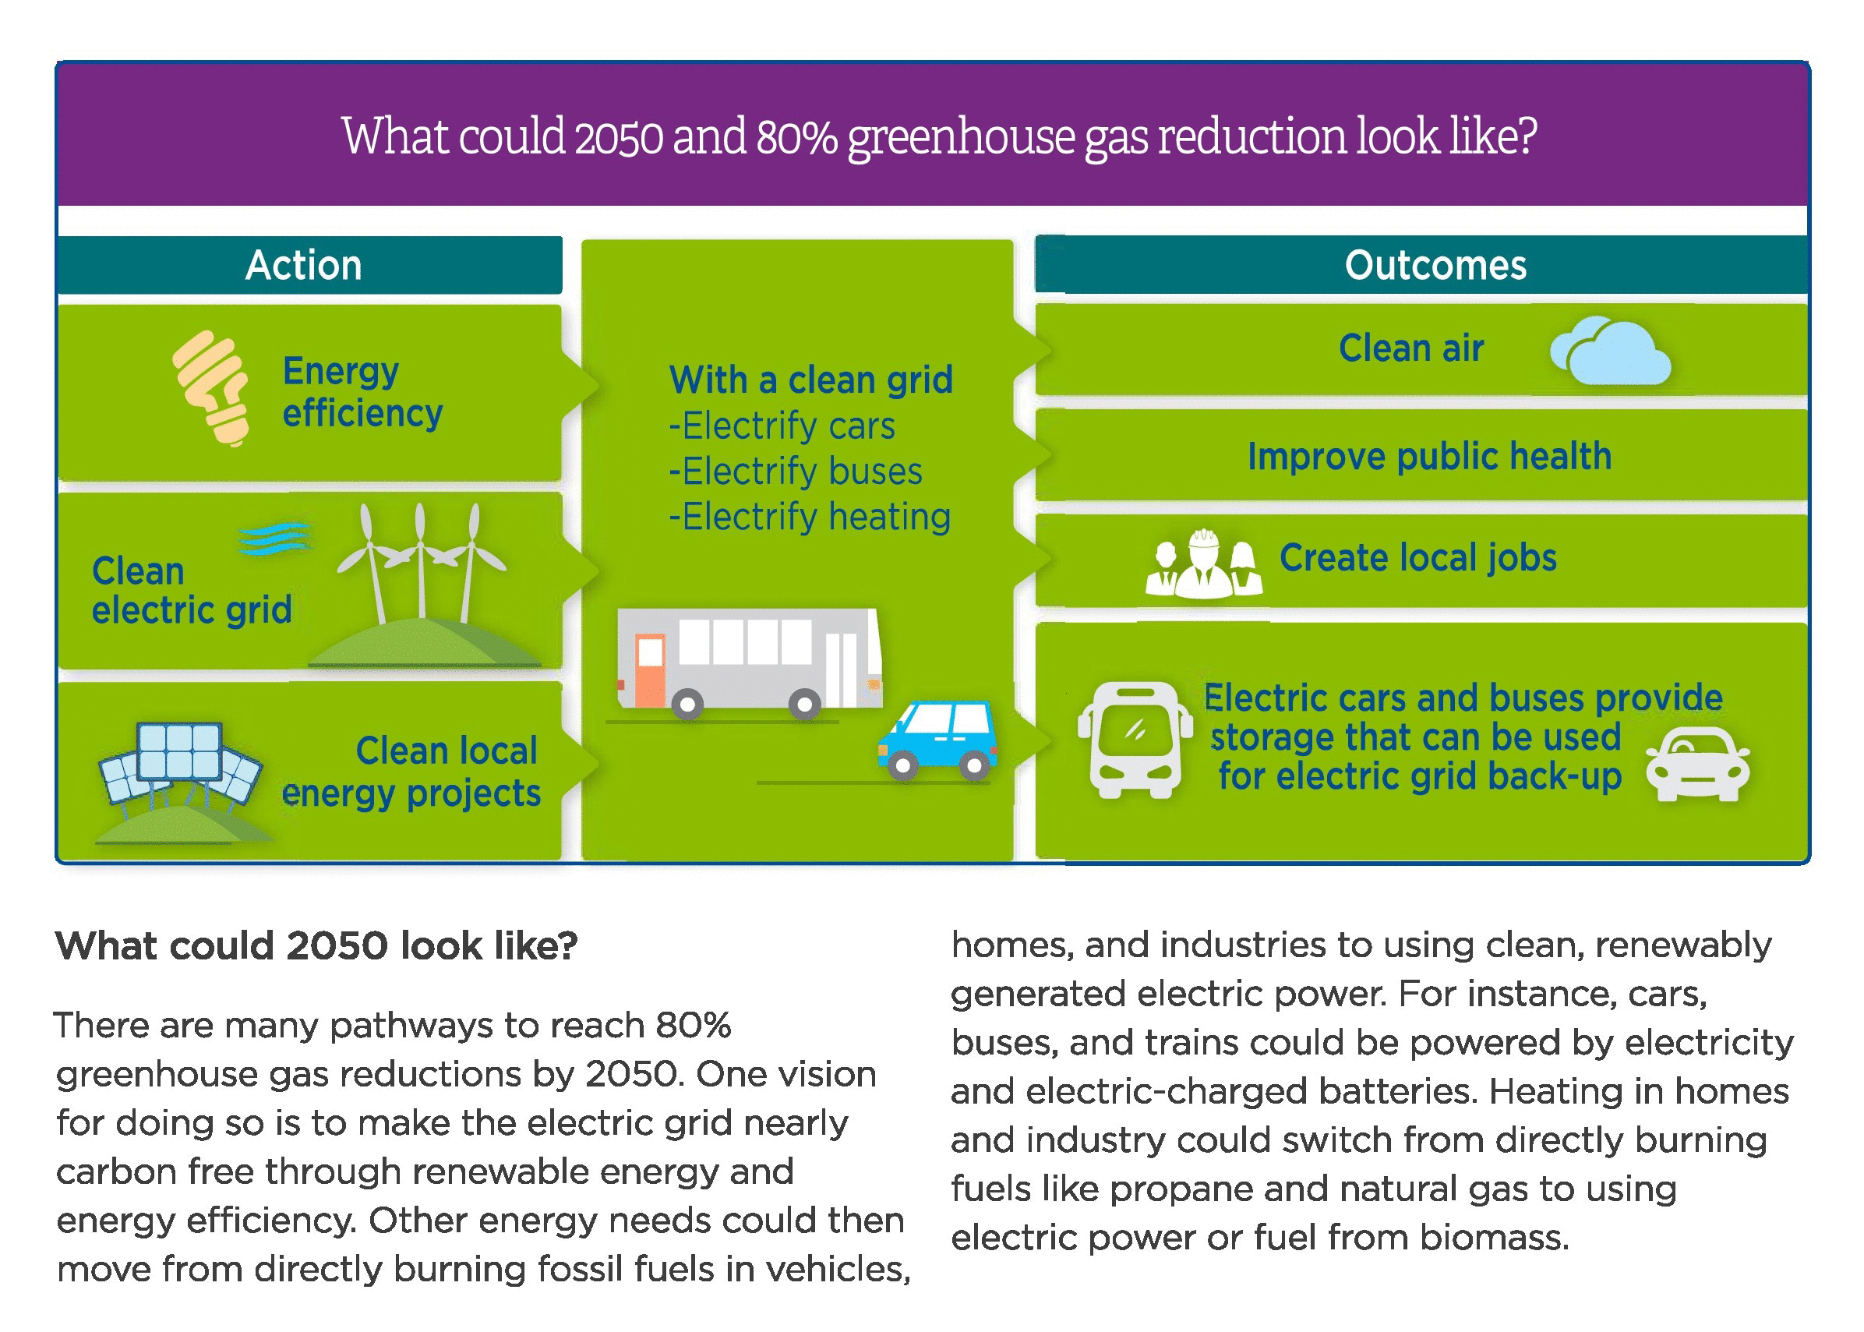
ONE - Reduce CO2 with your congregation’s buildings
- Maximize energy efficiency
- Purchase affordable renewable electricity
  - Wind source
  - Explore roof top solar options
  - Community Solar gardens
- Heating and Cooling – reduce costs, be ready long term to switch from natural gas to electricity
  - Efficient equipment, efficient appliances, zones
  - Carbon offsets for natural gas use
  - Long term – replacing natural gas with electricity

- Maximize energy efficiency
Call for a free energy assessment for your congregation’s building - EnerChange is funded through the Conservation Improvement Program and is able to offer its services at no charge. Schedule a free Energy Assessment for your congregation: call Michael T’Kach, Energy Efficiency Manager, EnerChange 952-562–8697 mtkach@enerchange.org , www.enerchange.org

How to find out your congregation’s Usage & Demand Charges - ask your congregation’s financial manager www.xcelenergy.com/staticfiles/xe/Marketing/Managed%20Documents/all-states-my-account-energy-consumption-guide.pdf

CEE’s Lighting Audits One-Stop Efficiency Shop® Lighting Retrofits A full-service lighting rebate program available to small businesses in Xcel Energy's MN service territory with an electric demand of 400 KW or less. http://mncee.org/Find-Programs/One-Stop-Efficiency-Shop-Lighting-Retrofits Call Cindy Kelly, 612-244-2427 ckelly@mncee.org

EPA Energy Star Guide for Congregations This 39-page guidebook provides congregational facility owners and managers with actionable guidance to improve energy efficiency easily and cost-effectively, with links to numerous resources that are available both from ENERGY STAR and a wide variety of other organizations. These resources are available to help you through the process of completing an upgrade. This guidebook breaks down the major activities that are involved in carrying out an energy improvement project. www.energystar.gov/buildings/tools-and-resources/putting-energy-stewardship-energy-star-guide-congregations

Benchmark your congregation’s energy use to prioritize improvements using the free EPA Energy Star Portfolio Manager tool www.energystar.gov/buildings/facility-owners-and-managers/existing-buildings/use-portfolio-manager

- Purchase affordable renewable electricity
Wind source – purchase 100% wind power for your congregation & members www.xcelenergy.com/windsource
Roof Top Solar Options
  - Find out if you have a good location for solar MN Solar Suitability Map http://solar.maps.umn.edu/
  - Your roof needs to last longer than the life expectancy of your new panels
  - Made in MN Incentives - application due dates Jan 1 to Feb 28 www.mn.gov/commerce/energy/topics/resources/energy-legislation-initiatives/made-in-minnesota
  - Tax Credits – Your congregation can lease your rooftop solar from a private company that uses investor tax credits to reduce the costs
  - Financing - Possible low cost or zero interest loans from the Center for Energy and Environment
- Lease to own Roof Top Solar Projects (zero down) save 10% on electricity – need 10,000 square feet of good roof top space to make it viable – good contractors include Sun Dial Solar www.sundialsolarenergy.com and Novel Energy. www.novelenergysolutions.com
Community Solar – might provide a more affordable choice, if your roof is not suitable
    - Subscribe first with your building and then encourage members to subscribe
    - Zero down, 10% electricity savings, no insurance or maintenance
    - www.allianceforsustainability.com/communitysolar

MN IPL Community Solar – in partnership with Cooperative Energy Futures
http://mnipl.org/what-we-do/teams-2/mnipl-solar-team.html
http://mnipl.org/justcommunitysolar.html

TWO – Engage your congregation’s members to take action at home

MN Energy Challenge/ Congregations
http://www.mnenergychallenge.org/Actions/Bring-the-Challenge-to-Church.aspx

Home Energy Conservation with Members at Home
- Enhanced Home Energy Squad visits – free energy saving presentations for congregations, Emma Struss Community Outreach Specialist 612.335.5828 estruss@mncee.org http://mncee.org/What-We-Do/Program-Design-and-Delivery/Congregations-Saving-Energy

Wind source – 100% wind power - encourage members to sign up. www.xcelenergy.com/windsource

Community Solar Gardens - Encourage your members to join a community solar garden www.allianceforsustainability.com/communitysolar

Community Solar Gardens
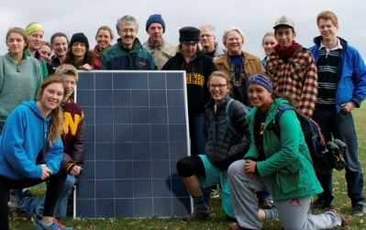  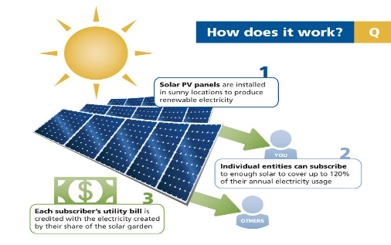 | - Join our Community Solar Garden!  - Help MN move toward a future with 100% renewable electricity!  - Save 10% on your monthly electricty bills.  - Partner with us! Your community group will receive a $50 donation for each household that joins our solar gardens through our landing page.  Sign up today to begin reserving your spot in our Solar Garden at  www.mncommunitysolar.com/sustainablecommunities  MN Community Solar is great local company that helped develop our State’s Solar Legislation that is committed to the pollinator pledge and diverse job training & placement and received Good Neighbor and Community Leader in the Consumer-Friendly Guide - http://fresh-energy.org/communitysolarpledge/  The Alliance is partnering with the Lake Street Energy Challenge and neighborhoods & congregations along Lake Street to sign up 500 households!  www.allianceforsustainability.com/communitysolar

THREE – Take action with your Community – other congregations and your city

Join a cluster of congregations in your city with creation care teams – www.afors.org/congregations

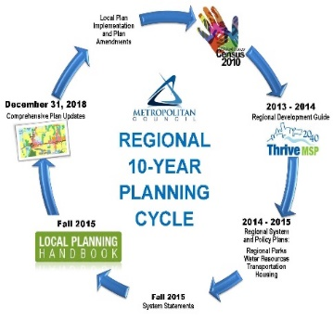 | Ask your City Council to include a Climate Resilience Action Plan,  Equity, Active Living & Food Access, in your City’s comprehensive plan by June 2017  Learn how and meet others from your city at one of our free Workshops in October for community volunteers & members of Environmental Commissions & Planning Commissions. Free, Register www.afors.org/sustainablecommunities  Met Council http://metrocouncil.org/Handbook/Plan-Elements/Resilience.aspx
In October 2016 the Alliance for Sustainability will work closely with the MN EQB, county and nonprofit resource partners, watershed districts and utilities to convene Resilient Cities Clusters of 5 or more cities in Anoka, Carver, Dakota, Hennepin, Ramsey, Scott & Washington County for city staff & commission volunteers to meet at an October launch with EQB staff & in January by county to share their draft comp plan goals & strategies. Find practical resources for your city to include resilience themes in your Comprehensive Plan http://metrocouncil.org/Handbook/Plan-Elements/Resilience.aspx
Meet with your peers from other cities in your county and with technical resource experts to
- Share and compare plan language, goals and strategies
- Connect with resources to map existing conditions, energy usage, climate vulnerabilities, etc.
Learn from cities that have developed action plans & implementation strategies through Xcel’s Partners in Energy, LoGoPep the Mayors Compact or MN GreenSteps to help meet our MN CO2 reduction goals.

October Metro Wide Workshop – Planning for Resilient Cities – Learning from the MN Climate Action Plan.
At this workshop co-sponsored by the Alliance for Sustainability and MN Environmental Quality Board, city staff, elected leaders and citizen volunteers can meet with expert staff from State Agencies find simple ways to include goals and strategies from the MN Climate Solutions & Economic Opportunities Action Plan into their City’s Comprehensive plan –
- Mitigation - Conserving Energy and moving toward renewable energy
- Adaptation – Helping your city infrastructure & residents be ready for extreme weather
- Health/Equity/Economy – improving the health & economic status of diverse and/or vulnerable citizens including active living and healthy food access strategies.

Follow Up Cluster Meetings – January 2017 – organized by the Alliance for Sustainability with host cities and counties in Anoka, Carver, Dakota, Hennepin, Ramsey, Scott and Washington County
City staff would meet up to share their sample plan language and strategies and could meet up with relevant county and watershed district staff.

July 20 Event Page – MN EQB forum on the MN Climate Action Plan
www.environmental-initiative.org/our-work/environmental-policy/climate-solutions-economic-opportunities

MPR Story - Elizabeth Dunbar – July 21, 2016, Minnesota must do more to cut greenhouse gas linked to climate change www.mprnews.org/story/2016/07/21/minnesota-climate-change-goals

Alliance Blog Link - http://allianceforsustainability.com/cseo

Planning for Resilient Cities Metro Wide Workshop (Oct 2016) and Resilient Cities Cluster Meetings (Jan 2017) http://allianceforsustainability.com/sustainablecommunities

FOUR – Take action for climate solutions in our state, nation and world

Minnesota www.mepartnership.org , www.fresh-energy.org www.afors.org/takeaction

National - Federal Policy for a fee and dividend http://www.citizensclimatelobby-mn.org/
Global – U.N. Paris Climate Agreement http://unfccc.int/files/meetings/paris_nov_2015/application/pdf/paris_agreement_english_.pdf

