Summary of High Impact Actions for Low Carbon Cities
High impact actions our cities can take together to achieve our city’s energy/climate goals
Resilient Cities and Communities Coalition www.afors.org/resilientcities
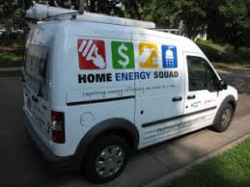 | Efficient/ High Performance Buildings Resource Guide Link  Action 1. Adopt an Energy Benchmarking Ordinance  Action 2. Commercial & Multifamily Engagement Partners in Energy, PACE
Action 3. Adopt a Sustainable Building Policy - high performance construction with city investment
Action 3. New Buildings - Educating Developers Xcel design assistance, PACE $ for Construction
Action 4. Supporting Legislation or Statewide Policy Improvements for better new construction
Action 6. Truth in Sale of Housing Inspections (adding an energy audit and energy score)
Action 7. Combine multi-family Energy Improvements with 4d Affordable Housing Tax Incentives.
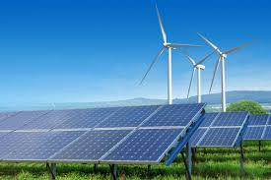 | Clean Energy Supply – Resource Guide Link  Action 1. Procuring Renewable Energy for City Operations  Action 2. Solar Ready Building Construction (City, businesses, multifamily)
Action 3. Expanding Rooftop Solar within City Businesses, Institutions (schools), Residents
Action 4. Support Legislation (2020 Centerpoint Energy) to advance renewable natural gas via PUC
Action 5. Support Legislation (2021) to Continue Xcel Energy’s Solar Rewards
Action 6. Cities commenting on Xcel’s Integrated Resource Plan (IRP) in April, May, June
Action 7. Additional Cities Helping with City of Minneapolis 100% Renewable Energy Resolution
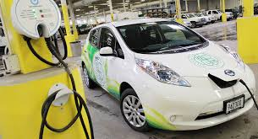 | Low Carbon Transportation/Land Use Resource Guide Link  - Electric Vehicles, Transit Investment  - Prioritize, bike, peds, transit  - Equitable, walkable, net zero TOD, in-fill redevelopment
Action 1. Support sustained state, regional & county transit investments. Reprioritize spending.
Action 2. Prioritize pedestrians, bikes, transit in public right of ways complete streets, reconstruction
Action 3. Plan for successful & equitable in-fill redevelopment - Net Zero, Equitable, Walkable, TOD
Action 4. Support increased adoption of Electric Vehicles - City Fleets, E.V. Charging Ordinance
Action 5. Shared Mobility - joint powers agreement between cities to regulate shared mobility
TO ADD – Climate Adaptation/Resilience
Green Infrastructure – Storm water, Flood Preparedness, Urban heat island, micro-grids/ storage
Forestry/Tree Policies, Habitat/Open Space, Pollinators, Soil Health, Sequestration, Farmland/Food/Ag
Additional Resources –
- USDN High Impact Actions https://www.usdn.org/high-impact-practices.html
- MN GreenSteps High Impact Policy List https://greenstep.pca.state.mn.us/page/ordinances
- Met Council Resources - soon - GHG annual reports for cities & scenario planning tools
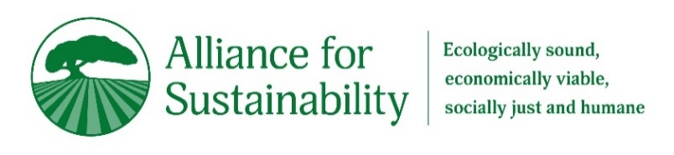 |  | For questions contact:  Sean Gosiewski, Executive Director,  Alliance for Sustainability  612-250-0389 | Sean@afors.org
MN GreenSteps High-Impact Ordinances List https://greenstep.pca.state.mn.us/page/ordinances
- HighImpact Policy Options for Low-Carbon Cities1 Phil Muessig, MN Greensteps 651-757-2594, Philipp.muessig@state.mn.us
USDN High Impact Actions List https://www.usdn.org/high-impact-practices.html
https://www.usdn.org/uploads/cms/documents/usdn_hips_update_-_september_2018_final.pdf
Please contact Garrett Fitzgerald, USDN Strategic Collaboration Director, garrettfitzgerald@usdn.org.
USDN will prioritize cultivating support for member action in the following areas:
Transportation  1. Major Public Transit Investments  2. Major Bike and Ped Investments  3. Community Electric Vehicles Adoption  4. Autonomous Vehicles Planning  Missing – reducing VMT through upzoning, net zero, walkable TOD, reducing free parking etc. | Building Energy Use  9. Electrification of Building Energy Systems  10. Energy Benchmarking for Large Buildings  11. Energy Upgrades at Trigger Events for Large Buildings  12. Zero Net Energy in Private New Buildings  ADD MN Specific  Sustainable Building Policies  Educating Developers on Design Assistance, PACE  Mpls 4D with solar and EE cost share grants
Energy Supply  5. Renewable Energy Procurement for Government Operations  6. Utility-Scale Renewable Energy  7. Community Installation of Renewable Electricity  8. State/Federal Advocacy on Energy Supply and Efficiency  ADD MN Specific  Xcel’s IRP  Minneapolis 100% Clean Energy Resolution  Centerpoint bill for renewable gas (via IRPs w PUC) | Consumption and Waste Reduction  13. Organic Waste Management  14. Construction Waste Management

