Getting Ready for Shared Autonomous Vehicles

Thomas Fisher, Director

Fleets of shared autonomous vehicles (SAV’s) will be on our roads within a decade as part of mobility services offered by both car and technology companies, and this transportation revolution will have a profound effect on our infrastructure and land use as well as on employment, the environment, and the economy. This may seem unprecedented, but we have gone through something like it before. Over a century ago, we switched from horse-drawn vehicles to automobiles because the latter were cheaper, cleaner and safer, and most people will switch to SAV’s for the same reasons. The transition from horses to cars in the early 20th century happened within a two-decade period of time, slowed down because of WW I, and the coming transition to SAV’s will happen just as fast – or faster, given the greater speed of our economy and the greater cost savings at stake. Which gives this topic some urgency, since the infrastructure and land use decisions we’re making right now will be affected by this transition.
Deploying geo-spatial technology long used by the military and aerospace industry, SAV’s will be electric powered, largely for cost and operational reasons, and will mostly be owned by mobility service companies that provide on-demand transportation when needed. This will greatly reduce the cost of transportation, greatly expand mobility to millions of who cannot drive, and greatly lower the environmental impacts of moving people and goods. SAV’s electric operation will decrease air and noise pollution and their continuous use during the day will largely eliminate the need for on-site parking stalls, lots, ramps, and garages. And SAV’s will also save thousands of lives and hundreds-of-thousands of injuries each year.
As with any major technological shift, SAV’s will disrupt some people’s lives. The millions who make their living selling, maintaining, and driving cars and trucks, for example, will experience substantial unemployment unless they can transition into higher-skilled mobility service work. The public sector, which currently gets revenue from gas taxes, parking meters, and traffic tickets will also take a financial hit, although the decreased amount of infrastructure needed and the increased amount of higher-value land freed up may offset the losses.
The transition to SAVs will likely happen more quickly than most of us imagine for economic reasons. As people move to using shared mobility systems because of lower costs, that will shrink the number of drivers who remain the cause of most accidents, which will increase insurance rates. That will prompt more people to stop driving, which will shrink the base even more, raising rates further to the point where auto insurance – where if it is still available – will become prohibitive to all but a very few. Another economic factor will be reductions in healthcare costs as driving - the most hazardous daily activity we do - disappears.
The following pages focus on the infrastructure and land-use impacts of SAV’s with suggested language for incorporation into comprehensive plans and with accompanying drawings that show the physical impacts. While we cannot know the full effect of SAV’s, we do know that they are coming and that this will happen during the period of comp plans being written right now. The Minnesota Design Center at the University of Minnesota stands ready to help communities prepare for this change and we would welcome a chance to have further conversations about this topic.

Streets and Roads

These diagrams show the nature of the change that SAV’s will bring to our roadway infrastructure. Rather than have multiple wide travel lanes needed for drivered vehicles, SAV’s only require one, eight-foot-wide travel lane in each direction, with the occasional pull over for dropping off and picking up riders. That drop-off lane can also be shared with bicycles. This leaves a lot of space for other uses, from widened sidewalks that allow for outdoor eating or commerce to green infrastructure that can shade walkways and accommodate storm water before it reaches the storm-sewer system. The challenge we face is how to transition existing streets designed for drivered cars to ones adapted to SAV’s. One strategy would be to use temporary measures, such as restriped roads, movable planters or flexible bollards that allow us to narrow the width and number of travel lanes at low cost as SAV’s begin to replace drivered cars. Likewise, parklets and other pop-up strategies can help streets transition to being more pedestrian friendly.

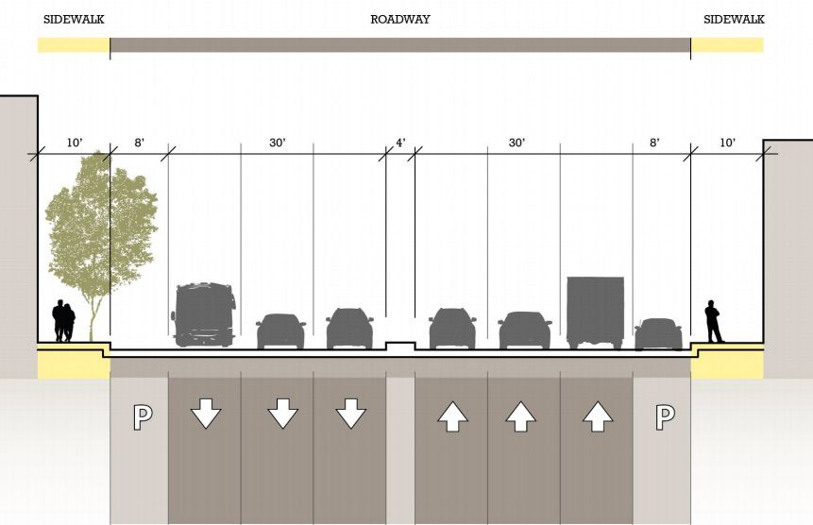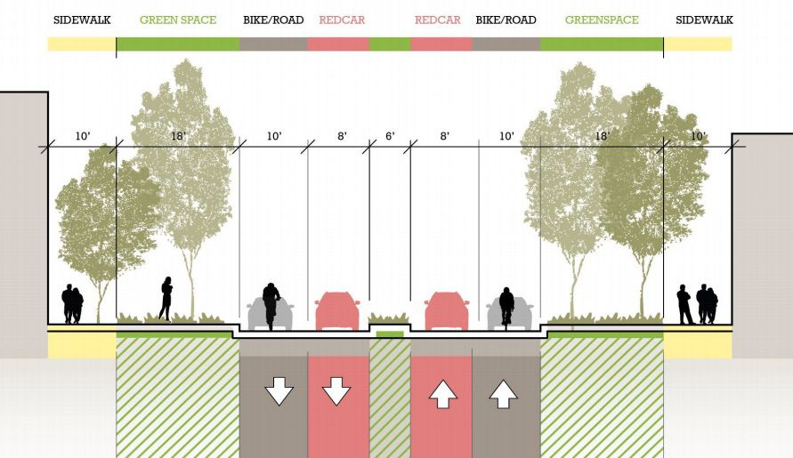
courtesy of Perkins + Will

courtesy of San Francisco Municipal Transportation Agency

Comprehensive Plan language: Preparing public right-of-ways for the transition from drivered cars to shared autonomous vehicles (SAV’s) will require an assessment of the rate of this change, attention to conflicts between the two types of vehicles, and the development of low-cost and temporary strategies that allow existing streets to switch to accommodating SAV’s as they become more prevalent. Making more space available for bikes, pedestrians, and green infrastructure should also be examined.

Residential Streets

SAV’s present opportunities in residential districts for homeowners and renters. As people increasingly share mobility services, the land devoted to driveways and the interior space taken up by garages becomes available for other uses such as bike and pedestrian access, community garden space, and drop-off and pick-up pullovers for passengers. And as garages are no longer needed to park vehicles – as opposed to storing other possessions – they might be able to be converted to such uses as accessory dwelling units, working space, and recreational or retail activities. This may require greater flexibility in terms of zoning to allow for mixed uses and more shared open space.

courtesy of Perkins + Will

Comprehensive Plan language: Residential districts should consider the impacts of shared mobility services in terms of the need for driveways, the use of yard space for shared activities, and the adaptation of garages for other purposes. This may require zoning changes or variances, depending on the demand among property owners and residents and on the rapidity of the transition to SAV’s.

Parking Ramps

SAV’s will make parking ramps as currently used largely unnecessary. Within the life of most of these structures, they will no longer be needed to store large numbers of vehicles, or at best, they will become places for SAV’s to park in the middle of the night, when few people are traveling. Even then, SAV’s can park in tight rows, as returning rental cars do today, and will take up much less space than drivered cars need now. To minimize the demolition of parking ramps, from now on, all should be designed to have flat floors, with inclines or spirals that can be taken out in the future as ramps get converted to other uses. These structures should also have a large enough floor-to-floor height (12 foot or more) that they can transform into housing, office, or production space in the future. Finally, parking ramps need to be designed with sufficient loading capacity to accommodate future uses. Ramps, for example, require 40 pounds per square foot, which is sufficient for multi-family housing but not for offices, which require 50 psf, or light industry, which require 100 psf. The need to build new ramps, given the number that already exist and given the nature of SAV’s, remains a question that every community and property owner should ask.

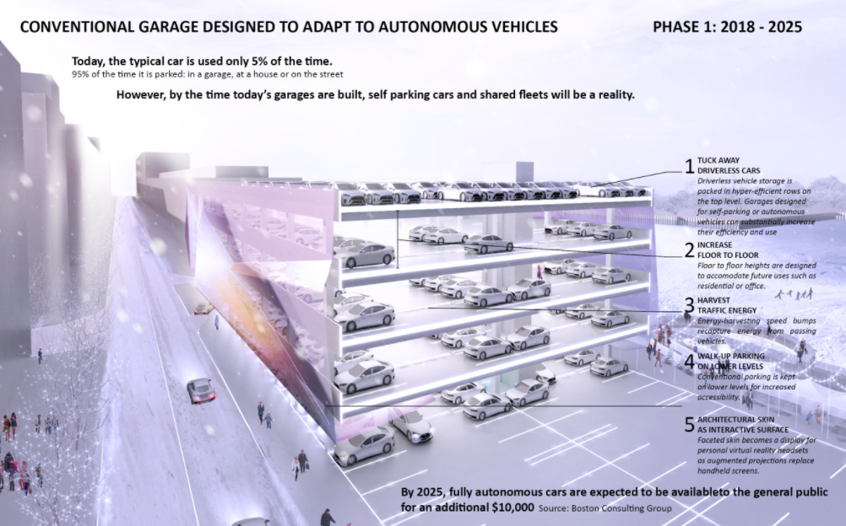
courtesy of Arrowstreet

Comprehensive Plan language: Structured parking ramps should be designed to transition to other uses over the life of the building. Ramps should have mainly flat floors with inclines or spirals able to be removed in the future without jeopardizing the integrity of the building; adequate floor-to-floor heights to allow for other uses such as multi-family housing, office, or light industrial; and sufficient structural capacity to accommodate the loading requirements of those other uses.

Parking Lots

The dramatic decrease in the demand for parking with SAV’s will free up a lot of the land now devoted to storing drivered vehicles. After the transition to shared mobility services, commercial, residential, and industrial properties will need street access and adequate curb space for dropping off and picking up people, allowing a majority of surface parking lots to get converted to other uses, from green infrastructure strategies such as constructed wetlands, parks, and recreation space to additional buildings to accommodate the need for more affordable housing, mixed-use facilities, and production-oriented activities. This will require a re-examination of parking requirements and an incentive system to encourage or allow property owners to transition their surface parking lots into other, more beneficial uses. These drawings show how, with the arrival of SAV’s, space formerly used for surface parking can enable municipalities to increase density and property owners to increase revenues on and the value of their land.

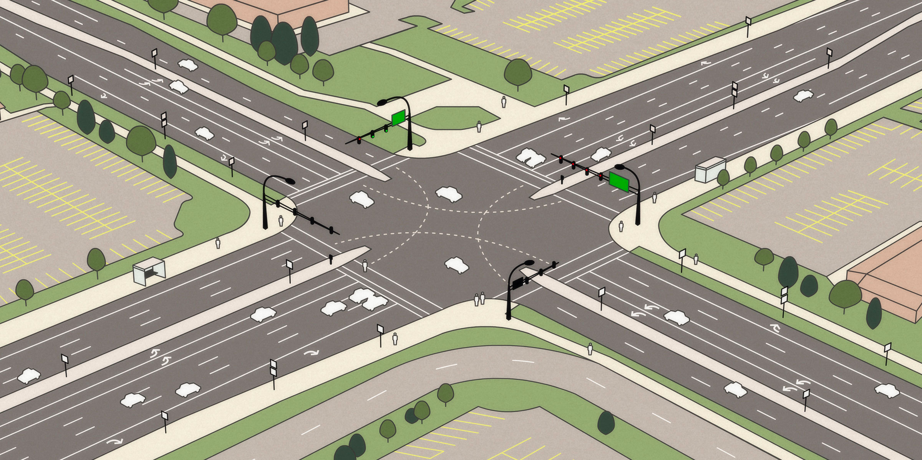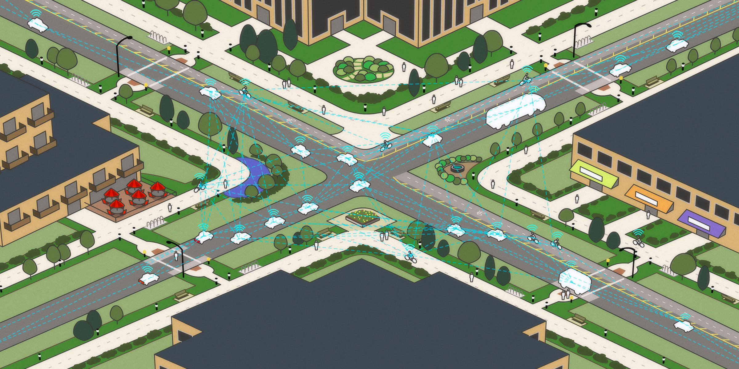
courtesy of the MIT Senseable City Lab

Comprehensive Plan language: Parking requirements for commercial areas should be evaluated as the transition to shared mobility services, with flexibility to accommodate property owners as their needs change. Incentives to encourage greater densities along commercial corridors and more green infrastructure in lieu of additional grey infrastructure should also be examined as conditions change.

