MN Resilient Cities Coalition
Elected Leaders, City staff and commission volunteers from 40 MN Cities collaborating to meet their community-wide energy, climate and resilience goals. www.allianceforsustainability.com/resilientcities
Contact Sean Gosiewski, Executive Director, Alliance for Sustainability, 612-250-0389 Sean@afors.org
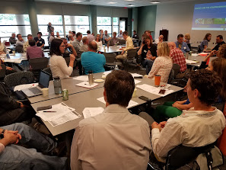 |  | Please RSVP to join us in person or on line for our  Spring 2018 Planning for Resilient Cities Workshop 11:30 a.m. to 1:30 p.m., Webinar Noon to 1:00 p.m.  Wed April 11, 2018  League of MN Cities  145 University Ave W, St Paul, MN 55103  Learn from and explore with metro City and County planning staff who will share
- Energy, resilience and equity-related goals and strategies from their draft 2040 Comprehensive Plans
- Implementation strategies and partnerships to expand building efficiency, use of solar and wind, job access, EV readiness and infrastructure resilience.
- How cities are working together to launch a MN Resilient Cities Coalition to advance their work
FREE Workshop & Webinar – please RSVP www.allianceforsustainability.com/resilientcities
Public Policy  Cities working together to ensure their interests are heard on state policy opportunities and challenges, i.e.  - Renewable energy standard  - Opposing local pre-emption  - See LMC policies below | Projects  Cities collaborating to help high-impact projects to go to scale metro wide – i.e.  - EV infrastructure planning  - PV solar for municipal buildings & businesses  - Business Benchmarking |  | Peer-learning  on current and future energy/resilience topics  - Cities sharing resilience/energy comp plan strategies April 5  - EV infrastructure – planning ways to invest VW settlement $  - Infrastructure funding strategies
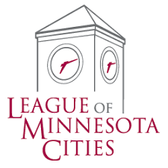 | League of MN Cities - 2018 Legislative Policies  The LMC 2018 City Policies publication was created with member input and approved by the LMC Board on Nov. 9, 2017.  www.lmc.org/page/1/legislative-policies.jsp  SD-63. State Support for Municipal Energy Policy Goals  The LMC calls on our legislators and state executive agencies charged with accomplishing the state’s energy policy goals to assist cities, townships and counties with tailored efforts to identify appropriate energy efficiency and renewable energy projects for undertaking at the local level.
Relevant Dockets at the Public Utilities Commission (PUC):
Integrated Resource Plans 17-286 Great River Energy Upcoming IRPs: Xcel Energy’s IRP due Feb1, 2019
2017 - 2019 Conservation Improvement Program (CIP) Triennial Plan 16-115 Xcel Energy CIP Triennial Plan
