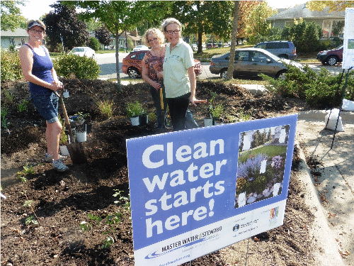 | Greening Your Congregation:  Being Water Wise  Networking Gathering & Workshop  Thursday October 15  6:15pm to 8:30pm  Pax Christi Catholic Church  12100 Pioneer Trail, Eden Prairie, MN 55347  www.afors.org/congregations
Meet active volunteers from congregations in Eden Prairie, Minnetonka & West Metro
Free event, snacks & refreshments provided!
Please RSVP at http://tinyurl.com/aforsrsvp
Please plan to bring 2 to 4 volunteers and/or staff from your congregation
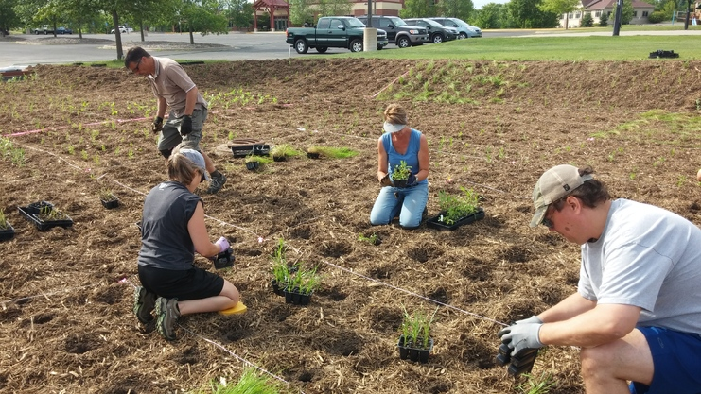  Raingarden Planting at Family of Christ Lutheran, Chanhassen |  | 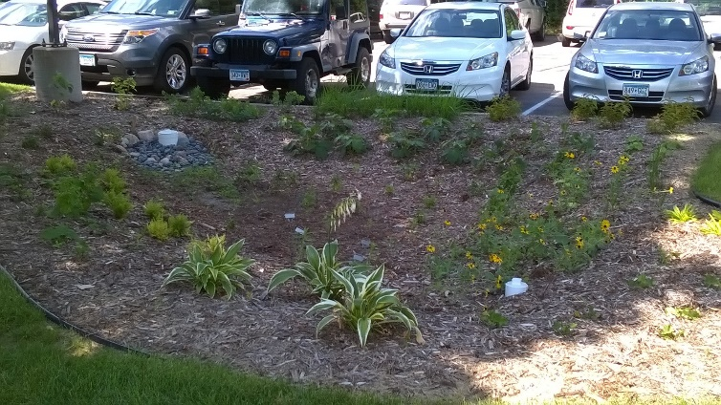  Raingarden Planting at Oak Grove Presbyterian, Blmngton
      - Learn about successful raingarden projects from Oak Grove Presbyterian and Family of Christ Lutheran. Share the projects your congregation is working on.
      - Find simple steps to soak in storm water and conserve on water use at your organization and home to protect our lakes, streams and ground water.
      - Meet volunteers active with other congregations in Minnetonka, Eden Prairie and the West Metro
      - Learn about project matching grant programs available from your Watershed & County.
      - Meet with an experienced landscape designer to brainstorm possible next steps (using google earth)
      - Featuring inspiring speakers from the Arboretum, Nine Mile Creek & Riley Purgatory Bluff Creek Watershed Districts, Cities of Minnetonka & Eden Prairie, congregations & Alliance for Sustainability.
Learn how to become a Master Water Steward at fall open house events www.masterwaterstewards.org
Questions? call Sean Gosiewski, Alliance for Sustainability 612-250-0389 sean@afors.org
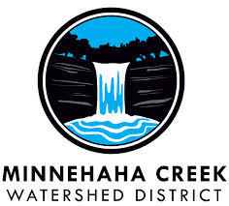 |  |  | 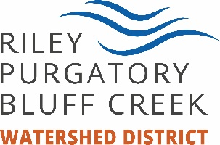  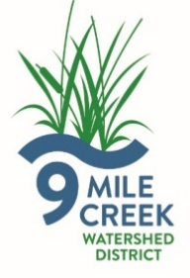

Resource People
Case Studies
- Oak Grove Presbyterian Church John Crampton 612-396-6010 jcrampt48@gmail.com

- Family of Christ Lutheran Pastor Jeanne Aamot (952) 934-5659 jeanne@familyofchristonline.com

Watershed Districts

Riley Purgatory Bluff Creek Watershed District
http://www.rpbcwd.org/news/cost-share-available-2014/
Michelle Jordan, Water Quality and Outreach Coordinator 952-607-6481 mjordan@rpbcwd.org

Nine Mile Creek Watershed District
http://www.ninemilecreek.org/CostShare/CostShareGrants.asp
Erica Sniegowski Education and Outreach Coordinator (952) 358-2276 esniegowski@ninemilecreek.org
Gael Zembal Education Programs (952) 204-9691 | gzembal@ninemilecreek.org

Eden Prairie
Leslie Stovring, City of Eden Prairie (952-949-8327, lstovring@edenprairie.org

Alliance for Sustainability,
2801 21st Ave S. Suite 100, Minneapolis, MN 55407
www.afors.org www.alllianceforsustainability.com/congregations
- Sean Gosiewski, Executive Director, Alliance for Sustainability 612-250-0389 sean@afors.org
- Louann Waddick, Master Water Steward, 612-715-3158 lawaddick@gmail.com
- Grace Sheely Water Master Water Steward, 952-974-1286 gracesheely@gmail.com

Hennepin County
Patience Caso 612-348-9352. patience.caso@hennepin.us

Green Partners Environmental Education Applications Due November 6, 2015
Green Partners Environmental Education program guidelines and application materials can be found at www.hennepin.us/GreenPartners. Note that changes have been made to the Branch and Root groups for the spring 2016 funding round.

Natural resource protection grants - Due November 6, 2015
Funding is available for projects that preserve and restore natural resources in Hennepin County. The goal of the grants is to support projects that implement best management practices that preserve and restore critical habitats, reduce erosion and reduce the amount of nutrients and sediment going into the county’s lakes, streams and rivers. Government agencies, organizations and landowners are eligible to apply. Applications are due by 5 p.m. on November 6. Learn more and apply. For more information, contact Jim Kujawa at james.kujawa@hennepin.us or 612-348-7338.

Master Water Stewards - please invite interested volunteers from your congregation to apply on line by December 15 to join the 2016 class of Master Water Stewards http://masterwaterstewards.org/become-a-master-water-steward/ to learn how to Help neighbors have a positive impact on water quality!
10,000 Salty Lakes: A Seminar for Residents -
Salt from our roads, parking lots, and driveways is polluting our lakes and creeks. Join the Nine Mile Creek Watershed District and Greg Wilson from Barr Engineering to learn more about the problem facing our local water bodies and what you, as a local resident, can do to help!
When: Wednesday, December 9, 2015 from 7:00 PM to 8:00 PM
Where: Minnetonka Community Center in the Community Room - 14600 Minnetonka Blvd Minnetonka, MN
Register: https://saltseminar.eventbrite.com

