Watershed Friendly Congregations
Questions? call Sean Gosiewski, Alliance for Sustainability 612-250-0389 sean@afors.org , www.afors.org
www.afors.org/waterstewards , www.allianceforsustainability.com/congregations http://www.hennepin.us/water
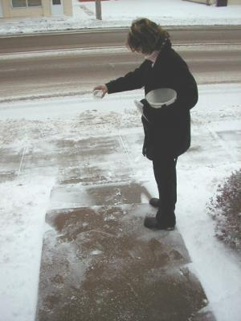 | ONE - Engage your members to take actions at home  - Include Monthly – Watershed Friendly Tips in your newsletter or bulletin.  - Host a Guest Speaker on Water Quality www.masterwaterstewards.org  - Collect Watershed Friendly Pledge Cards from members (with a rain gauge)  - Home visit coupons with Master Water Stewards  - Mow High/Sweep Clean - Change to healthy lawn care: mow to a 3” minimum, water as needed, Give away fescue grass seed packets  - Bag leaves and grass clippings or mulch and leave them on lawn  - Adopt curb/ storm drain - bag leaves and trash from the curb/storm drain  - Add a Rain Garden – $15 classes www.metroblooms.org or a  - Rain Barrel – low cost rain barrel sales www.recycleminnesota.org  - Minimize the use of salt in the winter and use alternatives  - Pick up after pets both in yard and on walks
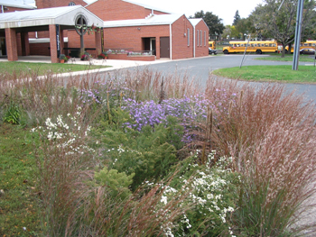 | TWO - Adopt Watershed Friendly Summer & Winter Maintenance for your congregation’s buildings and grounds www.mwmo.org www.minnehahacreek.org/education/workshops-and-events  - Discuss our maintenance check list with staff & volunteers and refer them to great on line training resources and classes  - Summer Maintenance - Change to healthy lawn care: mow to a 3” minimum, water as needed, never over apply chemicals and fertilizers, and look into native plantings. Attend a turf maintenance workshop. Bag leaves & grass clippings or mulch and leave on lawn to add nutrients  - Winter maintenance – shovel early, use less salt, low salt workshop
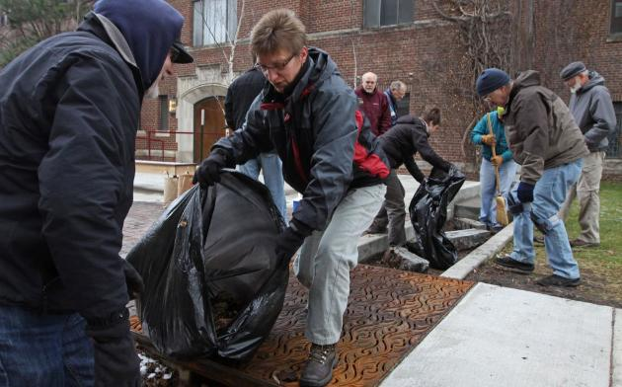 | THREE – Walk around your property with a landscape designer  with your staff & volunteers to look for opportunities to Install a Rain Garden, Rain Barrel or Parking Lot Improvement to capture and soak in storm water on site  Site Assessment – www.metroblooms.org , www.eorinc.com , http://earthwizards.com/  Grants – MCWD, www.minnehahacreek.org/grants  MWMO Tamara Schmitz, 612-746-4988 www.mwmo.org/stewardshipfund.html  Hennepin Co. NRICH www.hennepin.us/residents/environment/natural-resources-funding  Installation & Maintenance – opportunity to get help from  - County Master Gardeners http://hennepinmastergardeners.org/  - Metro Blooms/ Conservation Corps www.metroblooms.org  - Low Cost, Quality Contractor – Brian Nelson www.nelcolandscaping.com
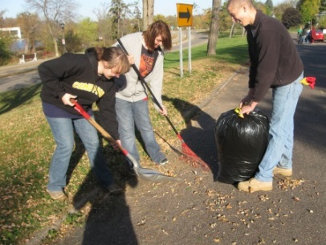 | FOUR – Engage your youth & adult volunteers in service projects  - Earth Day Clean Ups St. Paul April 18 or Minneapolis April 25 www.minneapolisparks.org/activities__events/events/earth_day_cleanup  Minnehaha Creek Clean Up - June 2015? www.minnehahacreek.org/events  - Fall Leaf Clean Ups – report the number of bags you rake from curbs and drains http://freshwater.org/community-clean-ups-for-water-quality/  - Clean Water Car Wash Pull cars onto the lawn & wash with bio-friendly soap.  - Host a Rain Barrel or Rain Garden Workshop or distribution event -  - Habitat Restoration Planting days - www.greatrivergreening.org
Watershed Friendly Congregations
Questions? call Sean Gosiewski, Alliance for Sustainability 612-250-0389 sean@afors.org , www.afors.org
and Master Water Stewards, Louann Waddick, 612-715-3158 lawaddick@gmail.com & Grace Sheely, 952-974-1286 gracesheely@gmail.com www.allianceforsustainability.com/congregations http://www.hennepin.us/water
ONE - Engage your members to take actions at home
- Include Monthly – Watershed Friendly Tips in your newsletter or bulletin.
- Host a Guest Speaker on Water Quality www.masterwaterstewards.org
- Collect Watershed Friendly Pledge Cards from members (with a rain gauge)
- Home visit coupons with Master Water Stewards
- Mow High/Sweep Clean - Change to healthy lawn care: mow to a 3” minimum, water as needed, Give away fescue grass seed packets
- Bag leaves and grass clippings or mulch and leave them on lawn
- Adopt curb/ storm drain - bag leaves and trash from the curb/storm drain
- Add a Rain Garden – $15 classes www.metroblooms.org or a
- Rain Barrel – low cost rain barrel sales www.recycleminnesota.org
- Minimize the use of salt in the winter and use alternatives
- Pick up after pets both in yard and on walks
Include Monthly – Watershed Friendly Tips in your newsletter or bulletin.
www.hennepin.us/business/work-with-henn-co/environmental-education-resources
- Adopt a Storm Drain (doc) - Tips on protecting nearby nearby bodies of water by keeping storm drains clear
- Earth-friendly Lawn Care Tips (doc) - Tips on maintaining a healthy lawn while minimizing your impact on the environment
- Five Easy Things (doc) - Five easy steps you can take to improve the water quality of lakes, rivers and streams
- Rain Gardens (doc) - Information about how rain gardens reduce runoff and resources that offer more information about installing rain gardens
- Water Quality Brochure (PDF) - 10 things that you can do to in your lawn, garden and around your house to improve Minnesota's lakes, rivers and streams

Host a Guest Speaker on Water Quality (have folks fill out a watershed friendly pledge card)
- Master Gardeners (612) 596-2110 http://hennepinmastergardeners.org/
- Water Stewards 763-219-1252 http://freshwater.org/master-water-stewards-a-community-approach-to-protecting-water
- Friends of the Mississippi River Katie Clower Community Engagement 651-222-2193 x 23 www.fmr.org
- Champlin UMC Member – Darby Nelson, For Love of Lakes www.darbynelson.com

Collect Watershed Friendly Pledge Cards from members (with a rain gauge as an incentive)
- Give a fescue seed packet to everyone who fills out a watershed friendly pledge card
- Input the Name, Email and Zip Code of your participants to receive our follow up survey at www.allianceforsustainability.com/congregations
- The Alliance will send them a follow up email survey in 3 months to see how they are doing with their actions, as part of our Hennepin County Green Partners Grant Project.

Name  Congregation/ or Neighborhood  Address  Zip  Email | 5 point pledge to Do My Part for Clean Water  You can fill this out one line at www.allianceforsustainability.com/waterpledge  We will get back in touch with you in 3 months with a short follow up email survey.  www.hennepin.us/residents/environment/protecting-land-water  www.masterwaterstewards.org www.afors.org/waterstewards

Please tell us what water protection actions you have taken to prevent pollution and share your thoughts on water protection.

- I believe protecting our water is good because _______________________________________________________.

- I believe I can make a difference in protecting our water
Agree I don’t know Disagree

- I feel a personal responsibility to protect the lakes, rivers and wetlands around my home.
Agree I don’t know Disagree

- I would take further action to protect water but this is standing in my way:

____________________________________________________.

- I feel a responsibility to teach others what they can do to protect and conserve water.
Agree I don’t know Disagree

Which of the following actions did you learn about and start doing as a result of this project?
 | I began doing this for the first time | I did this already but now I do it more | I didn’t do anything new
Keep a healthy lawn – Mow high 2 ½, to 3 inches, for deeper roots to soak in more rain,  I will try fescue grass seed (more drought tolerant) | ❑ | ❑ | ❑
Sweep Clean - Keep leaves, grass, and litter out of the street. | ❑ | ❑ | ❑
Adopt my curb and storm drain on your block and clean out leaves, grass, and litter. | ❑ | ❑ | ❑
Use my run off - Redirect downspouts from hard surfaces to the yard or garden, and/or use a rain barrel. | ❑ | ❑ | ❑
Reduce chemicals like herbicides, pesticides and fertilizers in your yard. If using chemicals, use according to the label instructions. Reduce the use of salt on sidewalks in the winter. | ❑ | ❑ | ❑
Install a rain garden to capture rainwater on your property. Use native plants to direct more rainwater into the soil.  - YES - I would like a visit to walk around my yard with a Master Water Steward  - YES - Metro Blooms Rain Garden Workshop | ❑     | ❑     | ❑

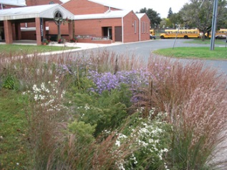 | TWO -Discuss our watershed-friendly summer and winter maintenance check list with staff & volunteers and refer them to great on line training resources and classes www.allianceforsustainability.com/congregations  Sean Gosiewski, Alliance for Sustainability, 612-250-0389 sean@afors.org ,
Watershed-Friendly Maintenance Check List for Congregations
Low Cost, Simple Actions Resources from www.mwmo.org , www.minnehahacreek.org , www.rwmwd.org and www.bluethumb.org
Summer Maintenance - professional training classes www.fortinconsulting.com/our-work/turfgrass
- Free training videos www.mwmo.org
Low Cost Actions
- Point your down spouts toward grass or rain gardens and away from paved areas
- Keep your sidewalks and parking lots free of leaves, dirt and sand with frequent sweeping.
- Switch to non-toxic cleaning products for your congregation’s janitorial staff.
- Keep your sidewalks ice free with less salt www.fortinconsulting.com/roadsalt.html
Lawn Care
Reduce Soil Compaction:
- Check with Rigid Wire Flag (test when soil is moist, but not dry/wet)
- Aeration (core-plug aerator/ soil augering/ deep-ripper, etc.)
- Add Organic Matter (well-aged leaf compost, add during aeration.)
3” Mow Height:
- 3” mow height: promotes deeper root growth to access moisture/reduces moisture loss
Mulching Blade:
- Mulching blade; finely chops grass clippings into lawn mulch (“Bag the Bagging”)
- Grass Clippings/ Leaves – keep out of sidewalks, street, driveway
Lawn-grass species selection:
- Use the best mix for your conditions (for your soil type/ compaction levels, sunlight and existing moisture conditions). Consider all fine fescue lawn mix or native blue gama lawn – is it appropriate for less used areas?
Smarter-Watering:
- Water when needed, targeted, reducing chance for excessive evaporation
- Timing; no watering between 11am – 5pm and in strong winds
- Utilize Low-volume drip irrigation/ targeted irrigation
- Rain-sensors; Moisture-Sensors: Smart-Timers/ Controllers
- Don’t Water the driveway & sidewalks: Adjust the head’s spray pattern
Rainwater Harvesting: Temporary Storage of rainwater for irrigation
- Rain barrels: 55- 90 gallons (i.e. VerdeStrategies.com $60 or www.recycleminnesota.org)
Low-water-use Landscapes
- Utilize Deep-Rooted Plants: Deeper roots = more drought tolerant
- Select “Right Plant for the Right Place” All plants like a specific soil type & moisture zone (wet, moist, dry) and specific sunlight conditions (full, part, shade.) Evaluate existing plants to pick plant community target type; (prairie, deciduous woods, coniferous forest, wetland, lakeshore, stream, etc.)
Rainwater Absorbing Landscapes
- Strategically placed tree, shrub and perennial planting areas (intercept)
- Vegetated Filter Swales (shallow ditch, when moving water to slow and filter)
- Rain Gardens (slightly sunken garden – to really soak in water)
- Permeable Hardscapes (for patios, driveways, sidewalks, etc.)
- Tree Care – water trees during drought (drip), plant trees to intercept rainfall
Winter Maintenance - shovel early, use less salt, low salt workshop – classes and events
Instructional videos www.mwmo.org and www.minnehahacreek.org/education/workshops-and-events
Free resources tips & videos at www.mwmo.org www.shinglecreek.org/pages/SaltApplicatorWorkshops
Free Training Video www.pca.state.mn.us/ Improved Winter Maintenance: Good Choices for Clean Water (15 Minutes)
Professional Training Classes www.fortinconsulting.com/our-work/road-salt

Watershed Friendly Congregations
Or Sean Gosiewski, Alliance for Sustainability 612-250-0389 sean@afors.org , www.afors.org
www.allianceforsustainability.com/congregations http://www.hennepin.us/water
THREE – Walk around your property with a landscape designer with your staff & volunteers to look for opportunities to Install a Rain Garden, Rain Barrel or Parking Lot Improvement to capture and soak in storm water on site
Site Assessments
Watershed District Cost Share Staff – www.minnehahacreek.org , www.mwmo.org
Master Water Stewards www.masterwaterstewards.org
Metro Blooms www.metroblooms.org ,
Earth Wizards, http://earthwizards.com/
Emmons Olivier Resources www.eorinc.com
Solution Blue http://solutionblue.com
Grants - MWMO www.mwmo.org/stewardshipfund.html
Grants – MCWD, www.minnehahacreek.org/grants
Elm Creek Watershed www.elmcreekwatershed.org
Shingle Creek Education Grants- $1,000 http://shinglecreek.org/pages/EducationGrants1
Hennepin Co. NRICH - $3k to $10k www.hennepin.us/residents/environment/natural-resources-funding
Installation & Maintenance – opportunity to get help from
- Hennepin County Master Gardeners http://hennepinmastergardeners.org/
- Metro Blooms/ Conservation Corps www.metroblooms.org
- Low Cost, Quality Contractor – Brian Nelson www.nelcolandscaping.com

FOUR – Engage your youth & adult volunteers in service projects to enhance our watershed
- Spring Trash Clean Ups with your city
- Earth Day Clean Ups St. Paul April 18 or Minneapolis April 25 www.minneapolisparks.org/activities__events/events/earth_day_cleanup
- Minnehaha Creek Clean Up - July 2015? www.minnehahacreek.org/events
- Fall Leaf Clean Ups – report the number of bags you rake from curbs and storm drains to see the amount of phosphorous you have captured http://freshwater.org/community-clean-ups-for-water-quality/
- Clean Water Car Wash Pull cars onto the lawn & wash with bio-friendly soap.
- Host a Rain Barrel or Rain Garden Workshop or distribution event - to construct rain barrels together, and leave with one or more for your yard
- Habitat Restoration Planting days - www.greatrivergreening.org

Find great resources, grants and advice for your congregation’s projects!
Questions? call Paris Dunning , Alliance for Sustainability 952-994-3746 parisdunning@gmail.com or
Or Sean Gosiewski, Alliance for Sustainability 612-250-0389 sean@afors.org , www.afors.org
www.allianceforsustainability.com/congregations
Saving Energy - through Energy Audits and Retrofits and helping your members save energy at home –
- Center for Energy and Environment, - Community Energy Services – Home Energy Visits Stacy Boots Camp, 612.244.2429 sbootscamp@mncee.org www.mncee.org/hes
- EnerChange Michael T’Kach, 952-562–8697 mtkach@enerchange.org www.enerchange.org
- MN RE-TAP, Mike Vennewitz, Coordinator 612-781-1307
www.pca.state.mn.us/index.php/topics/preventing-waste-and-pollution/assistance-and-resources/retap/minnesota-retap.html
- CEE- One Stop Efficiency Shop – Lighting Retrofits – assessments, installation, financing, http://mncee.org/Find-Programs/One-Stop-Efficiency-Shop-Lighting-Retrofits/
- CEE – Matching Grants for Nonprofits to make improvements www.mncee.org/Find-Programs/Energy-Grant-for-Nonprofits/
- LightingHouse USA. – high quality, low cost LED Lighting Retrofits, Sudhir Singh www.lightinghouseusa.com
Renewable Energy – through solar projects and wind power –
- Applied Energy Innovations - Installers of energy efficient furnaces, boilers, air conditioning, solar panels, solar hot air, wind power and geo thermal. (612) 532-0384 www.appliedenergyinnovations.org
- Windsource. – purchasing wind power from Xcel www.xcelenergy.com/Save_Money_&_Energy/For_Your_Home/Renewable_Energy_Programs/Windsource_for_Residences_-_MN
Water Quality – through rain gardens, water smart landscaping and low salt use –
      - Nine Mile Creek Watershed Erica Signowski, 952-358-2276 esniegowski@ninemilecreek.org. www.ninemilecreek.org
      - Emmons Oliver Resources Brett Emmons, 651.770.8448 Bemmons@eorinc.com www.eorinc.com
- Solution Blue Mitchell Cookas 651- 294-0038. mcookas@solutionblue.com www.solutionblue.com
- Earth Wizards Stacy Anderson, 763-784-3833 stace@earthwizards.com www.earthwizards.com
Local Food/ Community Gardening/ Composting –
- Gardening Matters Mallory 612-821-2358 mallory@gardeningmatters.org . www.gardeningmatters.org
- Hennepin County Environmental Services www.hennepin.us/environment
- Eureka Recycling www.eurekarecycling.org
Educating and Engaging your Members for environmental stewardship –
- Alliance for Sustainability, - Natural Step Framework action planning for congregations www.afors.org
- MN Interfaith Power and Light – speakers available www.mnipl.org
- Isaac Walton League, Bush Lake Chapter http://www.bushlakeikes.org/
- Cool Planet/ Speak Up Trainings - facilitating thoughtful Climate Conversations www.coolplanetmn.org
Sustainable Cities
- MN GreenStep Cities, www.mngreensteps.org ,
Supporting wise State and Federal Policies
- Clean Energy and Jobs Coalition – www.cleanenergyjobs.mn MN 350, www.mn350.org
- Citizens Climate Lobby, - Noon – First Saturdays of the Month - http://coolplanetmn.org/ www.citizensclimatelobby.org Fresh Energy –speakers available. www.fresh-energy.org
- Transit for Livable Communities www.tlcminnesota.org , www.transit4mn.org , www.movemn.org
Resource Groups
Watershed Districts/ Cost Share Programs –providing a technical advisor to speak with staff and volunteers in your congregation if you are thinking of doing a rain garden or community garden and can explain their cost share programs.
- Shingle Creek/ West Mississippi Watershed www.shinglecreek.org
- Minnehaha Creek Watershed District Cost Share Program (952) 641-4523 www.minnehahacreek.org
- Nine Mile Creek Waterhsed District Erica Sniegowski Education and Outreach Coordinator 952-358-2276 or esniegowski@ninemilecreek.org. www.ninemilecreek.org
- Capitol Region Watershed District Melissa Baker Coordinates stewardship grants 651-644-8888 Melissa@capitolregionwd.org
- Ramsey Washington Metro Watershed District Julie Vigness-Pint is the BMP Cost Share Coordinator 651 792-7959 julie@rwmwd.org www.capitolregionwd.org Technical Assistance Ramsey- Brittany Stringer 651-792-7979 brittany.stringer@rwmwd.org
- Ramsey Conservation District – Cost Share program http://www.co.ramsey.mn.us/cd/cost_share_funding.htm
- Mississippi Watershed Management Organization Education & Outreach Specialist (612) 465-8780 ext. 206 www.mwmo.org
City Staff
- City of St. Paul –Wes Saunders-Pearce. Zoning Title: Water Resource Coordinator Phone: (651) 266-9112. Wes.Saunders-Pearce@ci.stpaul.mn.us
- City of Minneapolis - Paul Chellsen - (612) 6732406 paul.chellsen@ci.minneapolis.mn.us permitting, fee credits, etc.
Design Assistance
- Ramsey Conservation District design assistance Ryan Johnson at (651) 266-7275 ryan.johnson@co.ramsey.mn.us http://www.co.ramsey.mn.us/cd
- Ramsey County Master Gardeners - 651-704-2080 rcmg@umn.edu www.co.ramsey.mn.us/mastergardener
- Metro Blooms – $60 for an on-site assessment, $60 for a schematic design. Sam Geer, Landscape Designer/Planner 212-380-7045 sam@metroblooms.org , Becky Rice 651-699-2426 becky@metroblooms.org www.metroblooms.org
- Ramsey Washington Metro Watershed District Sage Passi 651-792-7958. sage@rwmwd.org www.rwmwd.org
- Community Design Center - Tamara Downs Schwei 651‐228-7073 www.comdesignctrmn.org/
- Gardening Matters – for Community Gardens - Nadja Bernache 612-492-8964 nadja@gardeningmatters.org www.gardeningmatters.org
Design/ Build Partners – Many do an initial consultation over the phone and/or in person with congregations. Can help with designing bigger projects, provide engineering solutions and help develop project plans, budgets and grant requests.
- Solution Blue Mitchell Cookas 651- 294-0038. mcookas@solutionblue.com www.solutionblue.com
- Earth Wizards Stacy Anderson, 763-784-3833 stace@earthwizards.com www.earthwizards.com
- Emmons Olivier Resources Brett Emmons, P.E. 651-770-8448 bemmons@eorinc.com , Lisa Tilman, P.E. (651) 203-6015 ltilman@eorinc.com , www.eorinc.com
- Barr Engineering Company Fred Rozumalski, (952) 832-2733 frozumalski@barr.com Matt Metzger, P.E. Civil Engineer 952-832-2830 mrm@barr.com www.barr.com
- Ecological Gardens Paula Westmoreland, 612-998-1712 paula@ecologicalgardens.com
- EnergyScapes Douglas Owens Pike, EnergyScapes 612-821-9797 douglas@energyscapes.com
- Giving Tree Gardens - Russ Henry 612-227-0115 russ@gtgardens.com
- Harvest Moon Backyard Farmers Krista Leraas 612-209-2146 klerista@bitstream.net
- Dan Halsey; Permaculture Designer, SouthWoods Forest Gardens 952-226-6338 dhalsey@integra.net
- Permaculture Research Institute – Cold Climate – www.pricoldclimate.org
Steps to a creating a successful congregational
Watershed Stewardship Project
Compiled by Sean Gosiewski, Director, Alliance for Sustainability, 612-250-0389 sean@afors.org , www.afors.org
- Engage staff and volunteers from many committees in your congregation – Board, staff, buildings and grounds committee, green team, financial stewardship, education, youth, capital campaign other committees
  - Start with volunteers who are already into gardening and your green team (if you have one)
  - Check in with your custodial staff and building and grounds staff to hear their suggestions
  - Find a representative from your building and grounds committee and capital campaign committee
  - Gather these key people together for a presentation by a resource person on watershed friendly actions your congregation can consider. Include a discussion to engage folks and hear their ideas.

- Arrange a site assessment visit with staff from your watershed or metro blooms or design professional
  - They will help you to look for opportunities to capture storm water on your property.
  - If things look promising they can also help you arrange for taking soil borings to check on the permeability of your soils (clay vs sandy soil).
  - Ask your utility companies to tell you where the utilities are buried on site.

- Find a resource group/ partner that can help you with site assessment, site plans, creating a project plan and budget, filling out funding requests and supervising installation and maintenance.
- Envision your project – your resource partner can meet with your team, to walk around your property and facilitate a brainstorming session with your team to share the elements they want included in the project.
- For small projects you may be able to use the help of the Ramsey Conservation District, your Watershed District, Master Gardeners, Community Design Center and/or Metro Blooms to design and install your project.
- For larger projects you may need to secure funding to hire a landscaping and/or engineering firm.

- Contact your watershed district to find out about possible cost sharing programs (and what they fund.)
- Melissa Baker Coordinates stewardship grants for the Capitol Region Watershed District 651-644-8888 Melissa@capitolregionwd.org
- Julie Vigness-Pint is the BMP Cost Share Coordinator for the Ramsey Washington Metro Watershed District 651 792-7959 julie@rwmwd.org www.capitolregionwd.org

- Educate your members about the project benefits and seek matching funds to support your project –
  - Host an education hour for members to learn about the project
  - Create an informational display that shows how the project will look and explains the benefits
  - Include brief updates, an awareness building facts in your newsletter to build interest

- Contact your city and watershed early to know the approvals your project will need
- Erosion Control Permit required if disturbing more than 5,000 sq ft and/or 50 cubic yards of soil
- Stormwater Management Permit required if there will be a change in impervious surface or drainage on the site. If you are resurfacing a parking lot you likely will not trigger the stormwater management rule, but reconstruction of a parking lot will. Stormwater overflow outlet – for larger projects, work with your city to plan and get approval for how excess storm water will flow off site
- Plan and budget for how you will maintain your project – staff, volunteers, contractors.
- Community engagement and visibility –
  - Host a celebration/ dedication event
  - Create interpretive signage
  - Plan for future events to get your members out into the space
- Engage your congregation’s members in taking action at home –
  - Adult education forums – with a guest speaker
  - Rain Barrel Building Workshops http://www.capitolregionwd.org/rainbarrels.html
  - Updates in your newsletter
  - Volunteer projects with adults and youth
- Connect with your neighborhood and explore your watershed – to help with watershed friendly actions
  - Get out to enjoy your watershed http://www.capitolregionwd.org/recreation.html – Water Fest www.rwmwd.org Mississippi River Challenge, www.fmr.org
  - District Councils http://www.stpaul.gov/index.aspx?NID=1859
  - Community Design Center www.comdesignctrmn.org/
  - Community Gardens – www.gardeningmatters.org
  - Healthy Urban Forests – Forestry Department http://www.stpaul.gov/index.aspx?NID=4430
  - Como Lake Neighbor Network http://www.clnn.org/blog/
  - Bruce Vento Sanctuary/ Lower Phalen Creek http://lowerphalencreek.org/
  - Stewards of the Phalen Chain of Lakes http://phalenstewards.org , www.rwmwd.org
  - Community Clean Ups for water quality/ adopt a storm drain www.freshwater.org , www.afors.org
  - City Clean ups and Restoration Events – buckthorn removal. Andrew Rodriguez Volunteer Coordinator 651-632-2411 Andy.Rodriguez@ci.stpaul.mn.us Saint Paul Parks and Recreation Www.Stpaul.Gov/NaturalResources

- Engage your city – visit your city council to invite your city to adopt a resolution to become a MN GreenStep City www.mngreensteps.org and to learn about the water quality BMPs in the Blue Star Cities program and seek to become recognized as a Blue Star City www.bluestarmn.org

Case Studies of Storm water Management Best Management Practices
Minnehaha Creek Watershed District
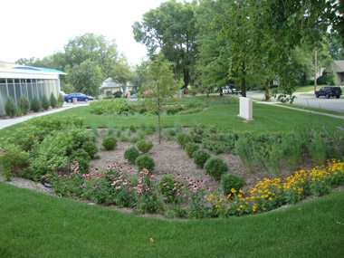 | St. Mary’s Greek Orthdox, (2010)  3450 Irving Ave S. Mpls , MN 55408 www.stmarysgoc.org  The extensive project was funded by donations from the congregations and the Minnehaha Creek Watershed District.  - St. Mary's Greek Orthodox Church Dick Andron, Chair of the Facilities Committee www.stmarysgoc.org Sylvia Kafkas Administrator (612) 825-9595 sylvia@stmarysgoc.org www.stmarysgoc.org  - Solution Blue Mitchell Cookas, (651) 294-0038 mcookas@solutionblue.com , www.solutionblue.com
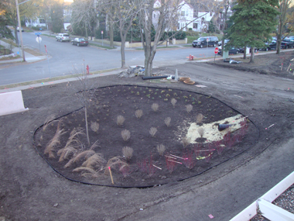  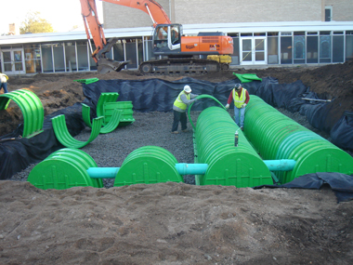  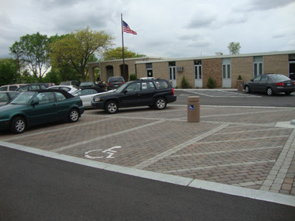 | Case study provided by Solution Blue - www.solutionblue.com  Overview –  St. Mary’s Greek Orthodox Church hired Solution Blue to address several site issues including improper drainage, overgrown landscaping, water leakage into the basement and deteriorating parking lots. Solution Blue provided the site analysis, conceptual planning, hydrologic modeling, landscape design, site engineering, permitting, Owner's representation, bidding assistance, prepared construction documents, provided construction oversight and prepared as-builts for a comprehensive network of site improvements and stormwater Best Management Practices (BMPs) throughout the Church’s 4-acre campus.  Challenges  - Site is adjacent to an impaired water body, which escalated the strictness of Watershed and City regulations  - The abundance of impervious surfaces generated high volumes of stormwater runoff that was reaching the City’s storm sewers (City’s “Stormwater Utility Fee” was costing the Church over $10,000 per year)  - Due to ongoing Church services, weddings and other events, construction was complicated and required maximum efficiency in use of space.  Solution and Results  Solution Blue designed and implemented a network of solutions to establish proper drainage, increase stormwater storage, improve the site’s aesthetics, provide infiltration and enhance the overall campus. Our team successfully executed the site analysis, planning, design development, permitting, bidding assistance, project management and also helped the Church obtain a sizeable cost-share grant because of the significant water quality and rate control improvements  - Implemented (5) rain gardens to improve water quality and reuse stormwater (pictured: Upper Left, Lower Right).  - Employed sub-surface chambers to increase stormwater storage and facilitate infiltration (pictured: Upper Right).  - Utilized permeable pavers to provide filtration of runoff and create attractive parking stalls (pictured: Lower Left).  - Selected primarily native plant species to increase the uptake of water and enhance drought resistance.  - Helped the Church eliminate their City of Minneapolis “Stormwater Utility Fee” (now saving Church over $10,000 per year).  - Provided assistance to help the Church obtain a cost-share grant (over $210,000) from the Minnehaha Creek Watershed District.

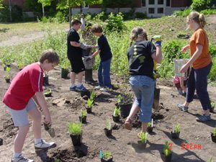 | Lutheran Church of the Reformation, (2003) www.reformationslp.org  2544 Highway 100 South • St. Louis Park, MN 55416  In 2003, LCR banished our Kentucky Blue lawn in favor of an earth-nourishing Prairie. We have made this bold move in response to our role and responsibility in the global issue of the future of our planet.  - Pastor Tom Mundahl- 952-929-0439 twmundahl@gmail.com  - Matching funding provided by the Minnehaha Creek Watershed District.

St. Luke Presbyterian, (2011)
3121 Groveland School Rd Mtka, MN 55391 www.stluke.mn
After creating a sustainability vision for their congregation using the Natural Step Framework and participating in a design process with the Permaculture Research Institute Cold Climate and Ecological Gardens their sustainability team will be creating a 3 acre food production, native prairie and rain garden demonstration site and will engage the students from the near by elementary school and adjacent neighbors. In 2012 they will be installing a rain garden with support from the Minnehaha Creek Watershed District.
- St. Luke Judy Gregg, Sustainability Team Volunteer (952) 474-3001 Amelia@mm.com www.stluke.mn
- Ecological Gardens Paula Westmoreland, 612-998-1712 paula@ecologicalgardens.com
Mississippi Watershed Management Organization
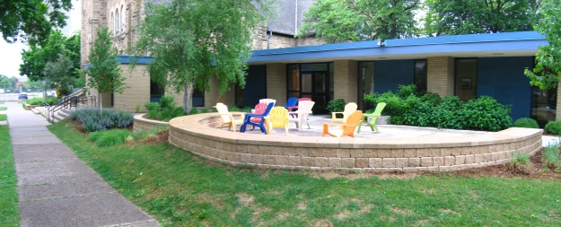 | University Lutheran Church of Hope, Rain Garden, Emmons Olivier Resources  601 13th Avenue SE Minneapolis, MN 55414 www.ulch.org /  Kathy Knudson, Volunteer 612-623-3562 kaknudson@comcast.net  Brett Emmons, Consultant Emmons Olivier Resources 651-770-8448 bemmons@eorinc.com , www.eorinc.com
University Lutheran Church of Hope – Site Master Plan & Implementation
A stormwater master plan was created for the entire site to reduce the church’s stormwater utility payments and provide a framework for campus beautification. The first implementation projects of this plan included: an outdoor gathering / classroom space with integrated splash pads, porous paving, integrated raingardens, and rainbarrels for irrigation/ reuse.

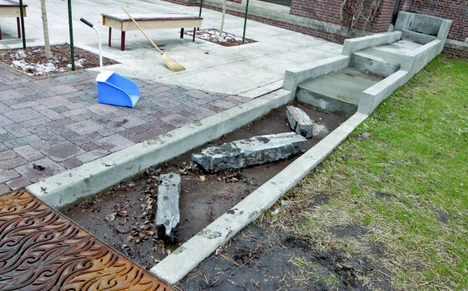 | Holy Trinity Lutheran Church (2010)  2730 31st St E, Mpls, MN 55406  The Rainwater Discovery Courtyard includes a rainwater cascade and a series of three Minnesota native plant raingardens with a dry creek bed that can hold up to 2,108 cubic feet of stormwater runoff captured from the building roof. Earth Wizards, Inc. designed the project. It was awarded a $50,000 Action Grant by the MWMO and the congregation raised $50,000 budget from donations.  - Stacy Anderson Earth Wizards 763.784.3833 stace@earthwizards.com  - Pastor Jay Carlson, 612- 729-8358 www.htlcmpls.org

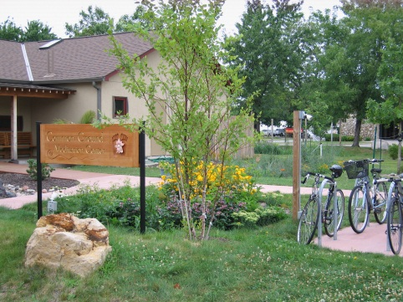 | Common Ground Meditation Center (2010 – 2011)  2700 E 26th St Mpls, MN 55406 www.commongroundmeditation.org  Mark Numberg Guiding Teacher 612-722-8260  This volunteer driven project reduced impervious surface on the center's property by 6,689 square feet and installed several raingardens and swales that will capture all stormwater runoff from the building roof and from the parking lot. The design includes Minnesota native plant species in the raingardens and dry stream beds to convey water from the building to the raingardens. They received a $33,000 grant from the MWMO.  Garden Design – Sage Passi 651-792-7958. sage@rwmwd.org www.rwmwd.org

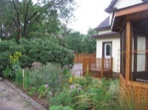 | St. Albert’s the Great (2010)  2836 33rd Ave S (612) 724-3643 www.saintalbertthegreat.org  Installed rain gardens around a gazebo behind the Parish Center offices.  http://www.bluethumb.org/projects/47/

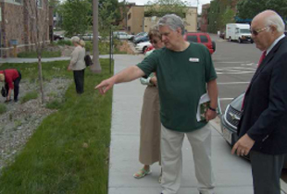 | Plymouth Congregational Church (2007)  1900 Nicollet Ave (612) 871-7400 www.plymouth.org  www.plymouth.org/about/caring_for_creation.php  Construction of a new education wing included grading for a rain garden and installation of overflow pipes to the street after being told by the City they had too much impervious surface. Caring for Creation committee volunteers helped plant native plants using a design by EnergyScapes, Inc. They continue to maintain the rain garden and dry prairie.

Gardening Matters  www.gardeningmatters.org | Questions to consider when starting community garden with your congregation  Gardening Matters 612-821-2358 - info@gardeningmatters.org  http://www.gardeningmatters.org/resources/startup
Have members of your church ever thought about growing food with and for others in your community? Want to do so but don’t know how to get started? Here’s a list of a few things you might want to think about before you get started:
Ask yourselves these questions:
- What is our vision – why are we doing this and what outcomes and goals do we hope to achieve?
- What sort of garden do we want – a parceled out community garden style (where each person/family has its own parcel) or a communal site where all work together?
- If we have a parceled out community garden can we ask/require participants to donate a certain amount for our community’s hungry members?
- Do we have land to do this? If the church has no space, perhaps a parishioner does and would like to share it and open it up for others to help.
- Do we have the leadership and long-term commitment to carry this out? You will probably need a couple of folks who are passionate about having a garden and following through with making it happen.
- Do we have enough volunteers? You probably will need 8 – 10 active volunteers.
- How will we get input into decision-making? Who will be the ultimate decision-makers?
- What are beliefs and values that will guide this project?
  - Regarding the land
  - Regarding people in need
  - Regarding your community (parish, neighborhood, girl/boy scout troop, etc)
- What skills and resources do we have and which ones do we need to seek?
- Who will be the recipients? Will they be the growers themselves or others in our community? If it will be others (e.g. food shelf recipients, gleaners, neighbors), do we know about them?
- What are their needs and desires when it comes to produce?
- Will the recipients be partnering with us at the site?
- What size garden can we best manage?
- Is water accessible and can we get the tools we need?
- How is our soil? Does it need to be tested and improved?
- How will the land be managed and maintained? Who will be responsible for that?
- What crops do we wish to plant (and have we discussed this with the recipients or gotten their input into our decision)?
- How will the produce be harvested and distributed? Will the growers take it home? Will we drop it off at a food shelf? Will someone come to pick it up?
- Who will be involved as volunteers? How many do we need? How often does each volunteer work? How many weeks and months will we need volunteers?
- What communications will be necessary and how will they be handled?
  - To our faith community?
  - To the volunteers?
  - To the recipients?
  - To our partners/donors/supporters and others in the broader community?
- What will this cost? Is there money budgeted or do we need to raise funds and ask for donations?
- How soon can we get started?
Thanks to the garden leaders at Guardian Angels Catholic Parish in Oakdale, Minnesota, as well as to other congregational gardeners in the Twin Cities metropolitan area for input.
Gardening Matters, Minnesota FoodShare -- GardenShare project http://mnfoodshare.gmcc.org/index.php
How to Start a Community Garden
Gardening Matters 612-821-2358 - info@gardeningmatters.org
www.gardeningmatters.org/resources/startup
THE BASICS
So you want to start a community garden! Here are some of the main pieces of advice Gardening Matters has gleaned from meeting with dozens of gardeners.
THE COMMUNITY
Aim for at least ten people committed to establishing a community garden.
Ten people working together means that no one person is being tapped out.
Give it at least a year before breaking ground. The time spent planning is essential…the more planning, the more successful the garden.
Community organizing is key to long-term success of the garden. Do it well,do it smart. Save yourself from backache or heartache!
Local solutions are best for long-term sustainability. Look at resources already available in the community for starting a garden and include these folks early on and invest them in the planning process.
Learn from other community gardeners. Go to the Community Garden Directory online and visit other community gardens. Get on the community gardener listserv, COMGAR, to connect with community gardeners for advice, support or feedback. (both accessible from www.gardeningmatters.org)
THE GARDEN SITE
What is available within the neighborhood? Walk, bike, drive around to see where land might be available.
What will the community garden be for? Beautification, land production, youth involvement? Who will be involved in the garden?
Research to see who owns the property of potential sites. What are their plans for the property?
Identify possible water sources, such as a neighbor, hydrant, or see if there was infrastructure there before and water-hookup to a main is possible.
What’s the next step?? Give Gardening Matters a call and check out the step-by-step Community Garden Start-Up Guide available from our website

